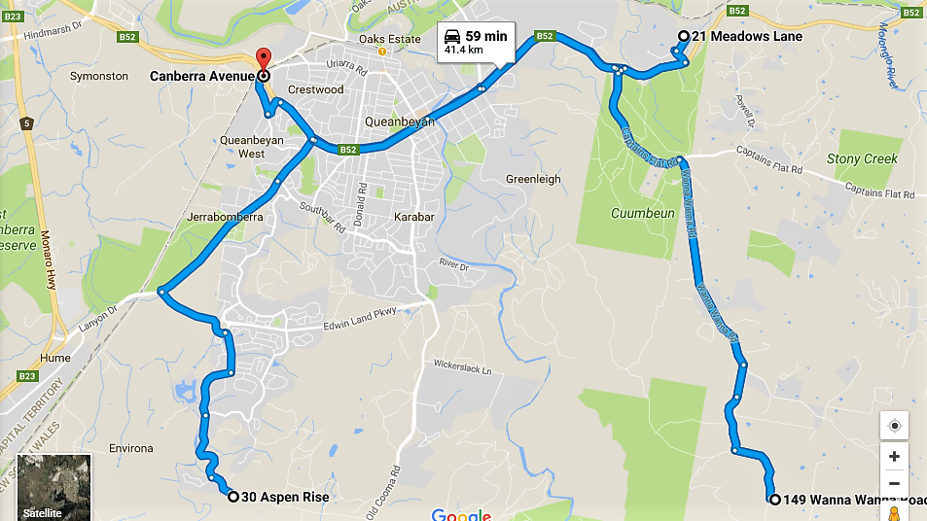

**Tour Rouge**, 21 Meadows Lane, Carwoola

Directions: heading east on the Kings Hwy B52, 1km after the Captains Flat turnoff, turn left into Weetalibah Road, then first right into Meadows Lane.

**Wanna Wanna**, 149 Wanna Wanna Road, Carwoola

Driving directions: From Queanbeyan take the Kings Hwy B52 to the Captains Flat roundabout, turn right and travel on Captains Flat road for 2.2 km and then turn right into Wanna Wanna Road.

**Pillans garden**, 30 Aspen Rise, Jerrabombera

Driving directions: travel east on Canberra Ave B52. At the roundabout take the exit onto Lanyon Drive, then take exits to Tompsitt Drive, Jerrabomberra Pkwy, Bicentennial Drive and Waterfall Drive. Turn left into Aspen Rise.